**Hands On Labs for AZ-204**

**AZ-204:**

Microsoft has a Github page that contains labs for AZ-204:

<https://github.com/MicrosoftLearning/AZ-204-DevelopingSolutionsforMicrosoftAzure>

This gives you step-by-step instructions for creating resources in the Azure Portal, and even deploying sample code into web apps.

e.g.

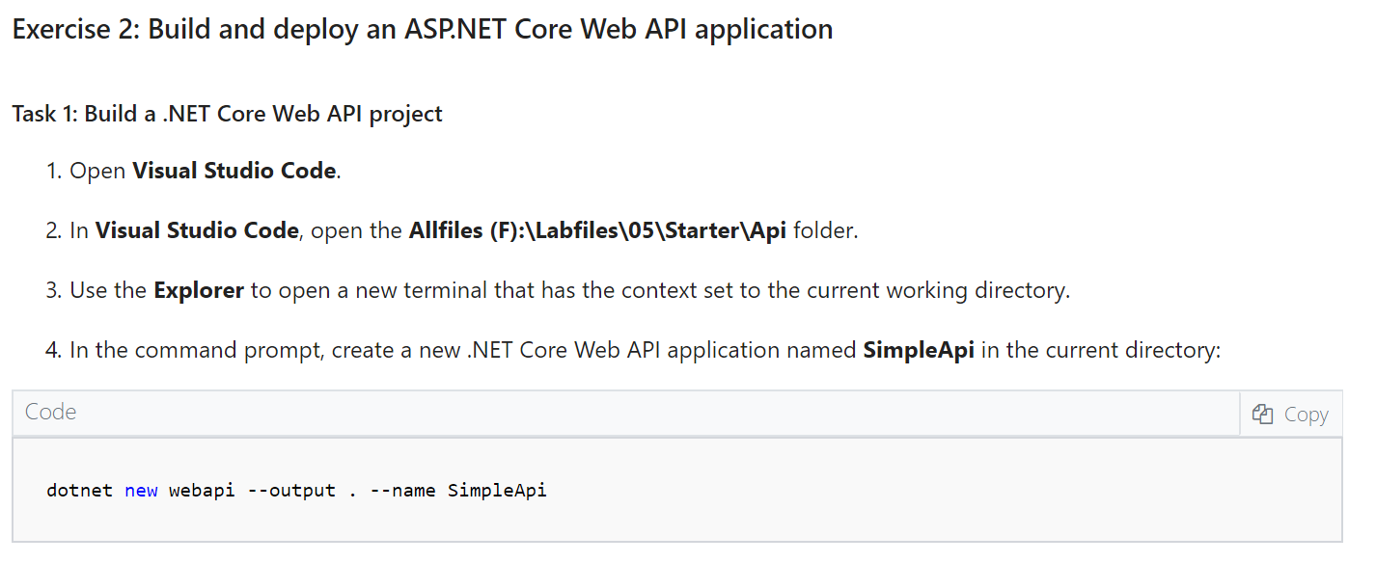

Try this, and hopefully, this will enhance your skill level with Azure Development.

Since this is a Microsoft supported GitHub repository, I can't help debug any issues. But it should help you learn the topic.